CLOUD COMPUTING LAB

CAT-2

1934049 Subash

1934047 Srijith

1934038 Saran Prasath

**Problem statement :**

Our client had built an online platform for creating projects in a team. He needs to design a subscription page for the website .Subscription is basically to earn from the users who use the site.

Solution:

We have done a web page with three plans for the users to select from.The plans start with a free plan ($0) to $89 /month plans. The client can able to earn from this work for every user who subscribes.

**Dockerfile**

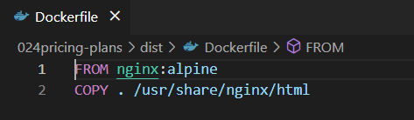

**Building Docker image:**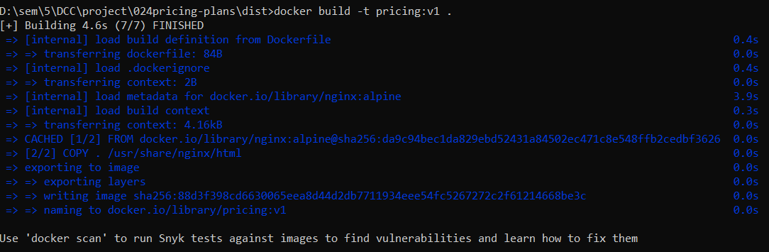

**Running image:**



**Image caching:**



Layer caching:

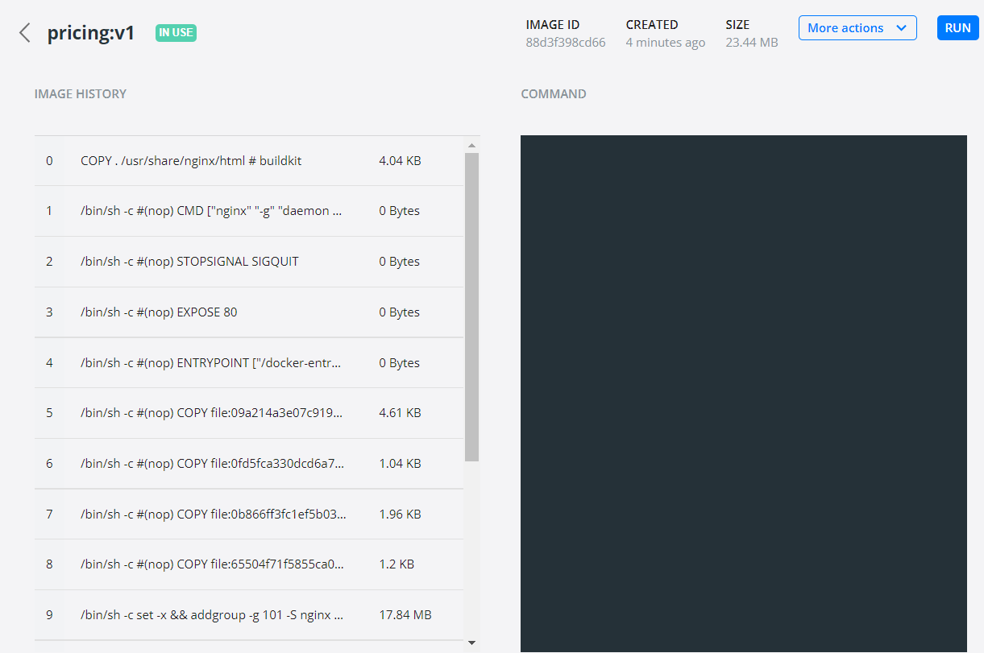

**Container:**



**Container Service exposure:**

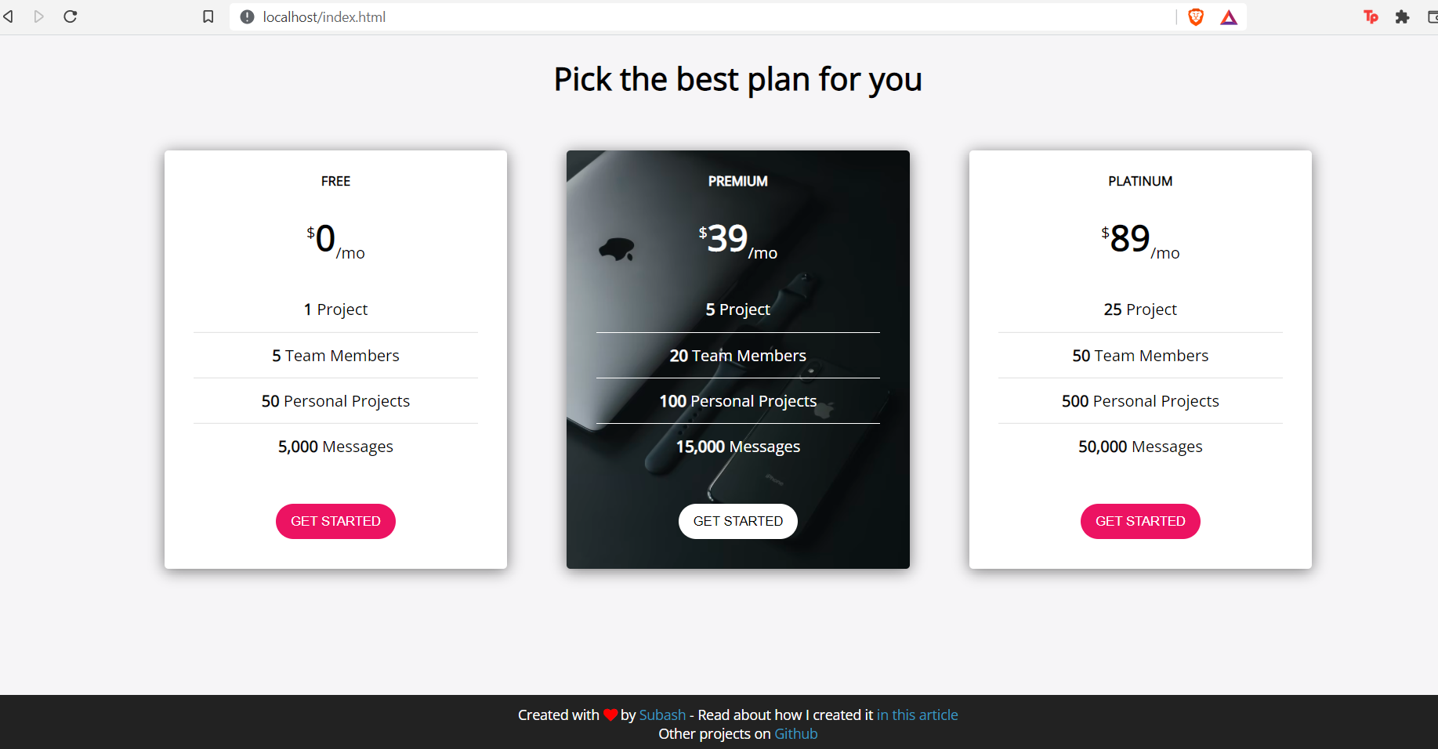

**Docker logs:**

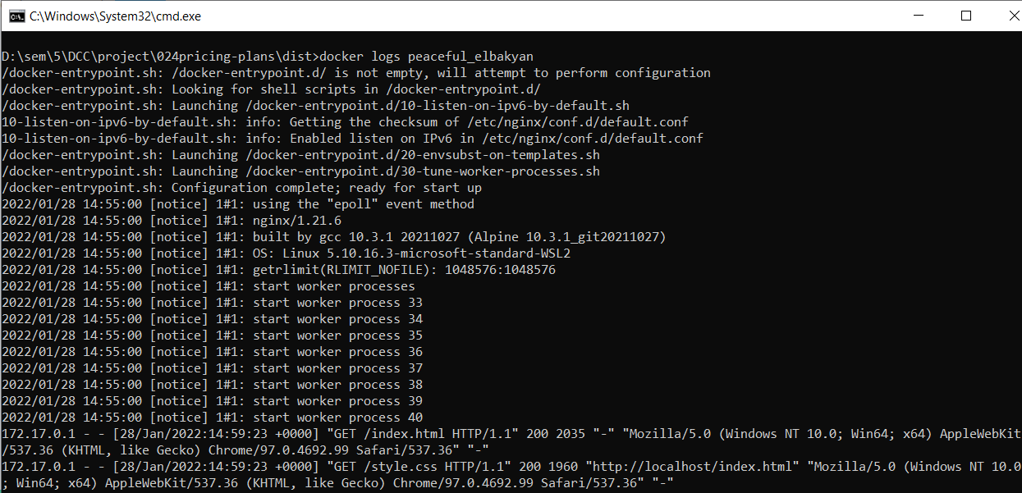

**Executing into the container:**

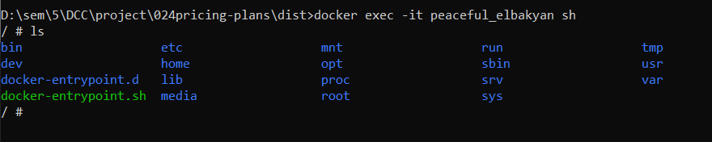

**Kubernetes:**

Starting minikube:

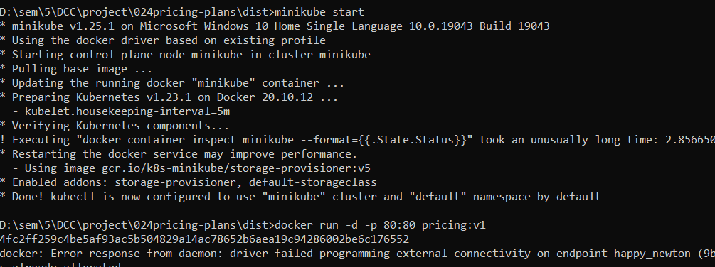

**Creating namespace:**

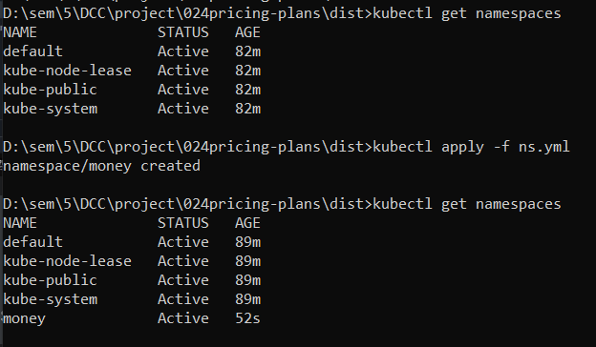

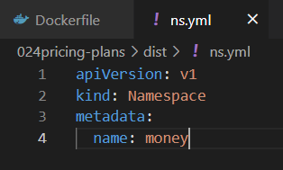

**Creating pod:**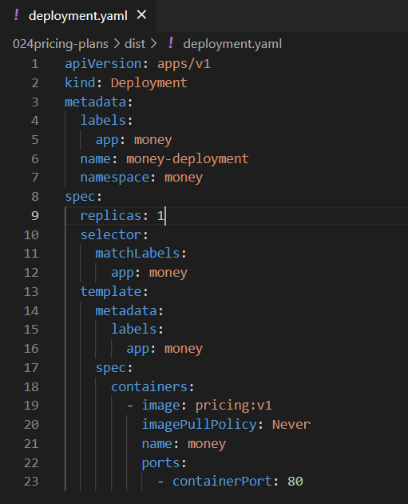

**Pod deployment:**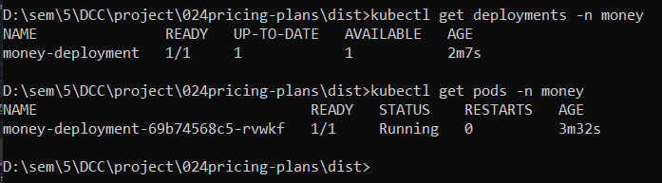

**Configuring deploying pod with 2 replicas:**

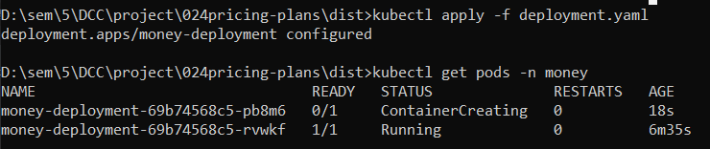

**Service Exposure:**

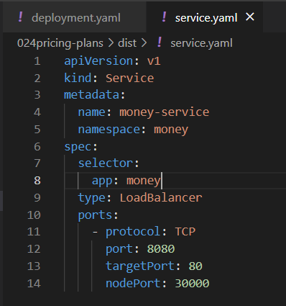

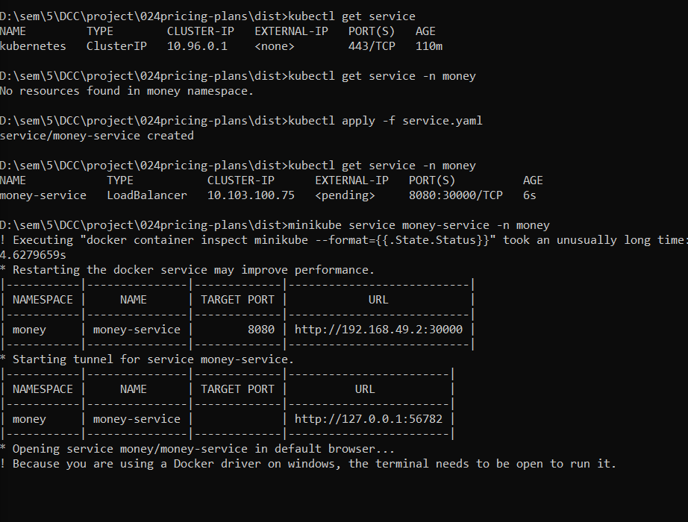

**Hosted Webpage:**

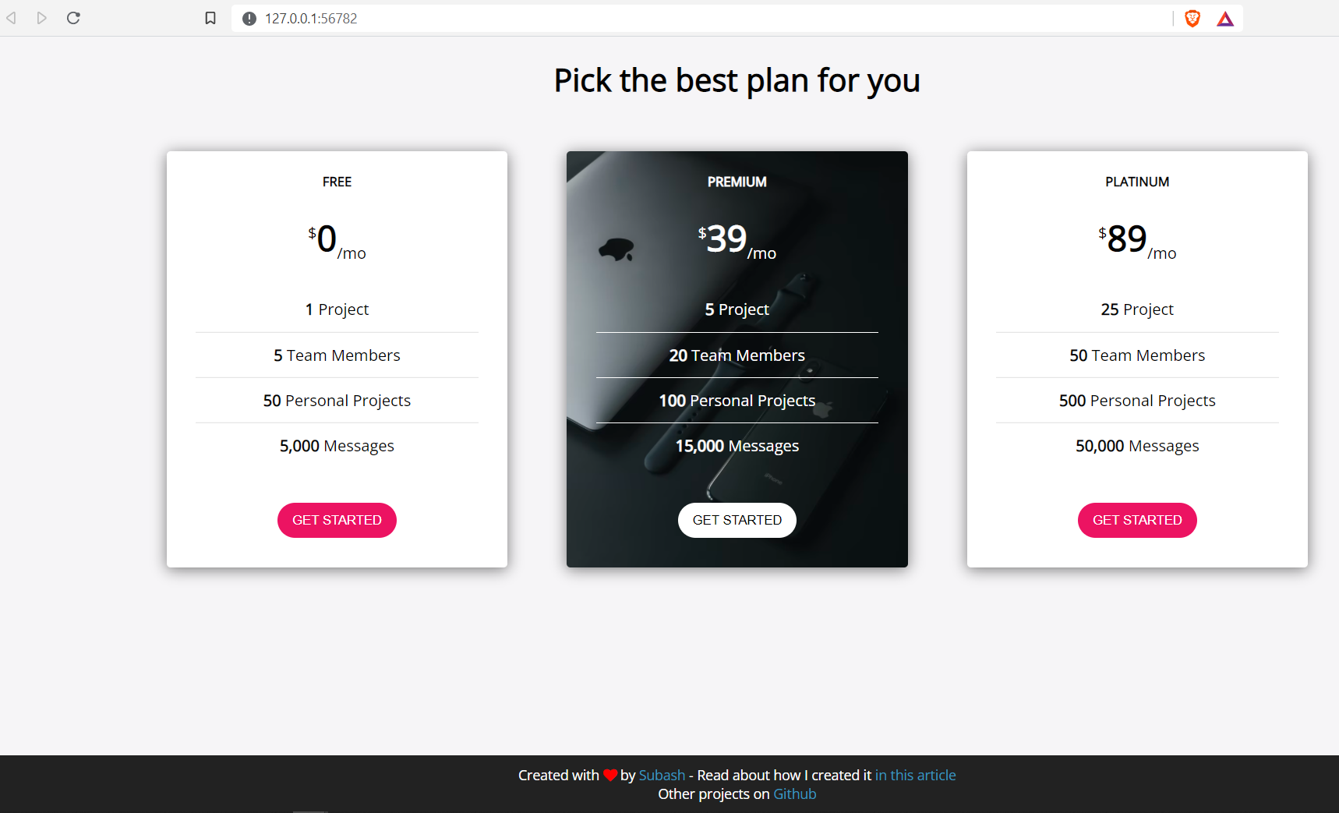

**Resource limitation:**

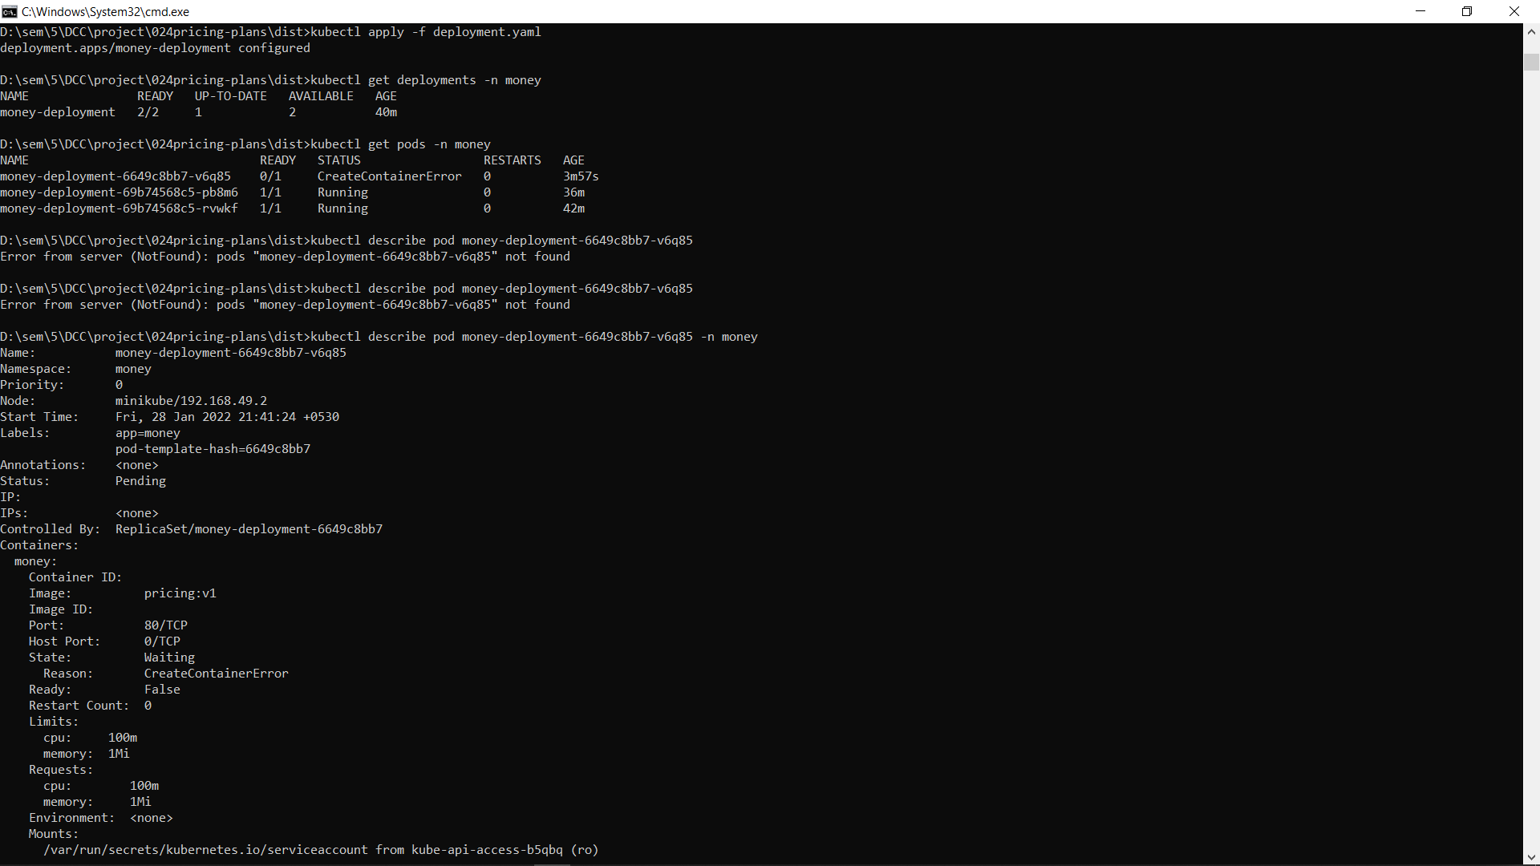

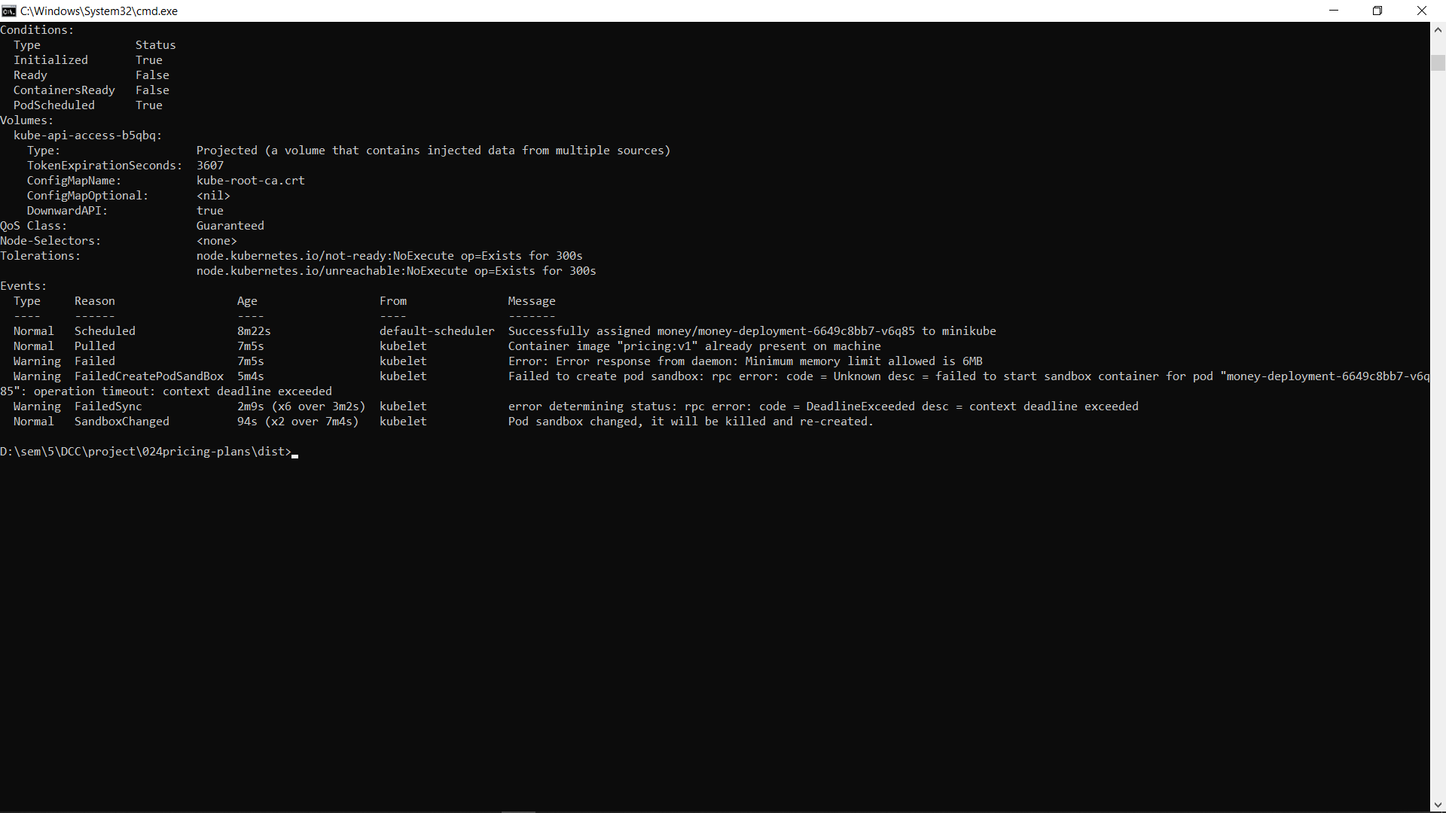

**ROLLBACK STRATEGY**

**Version-2**

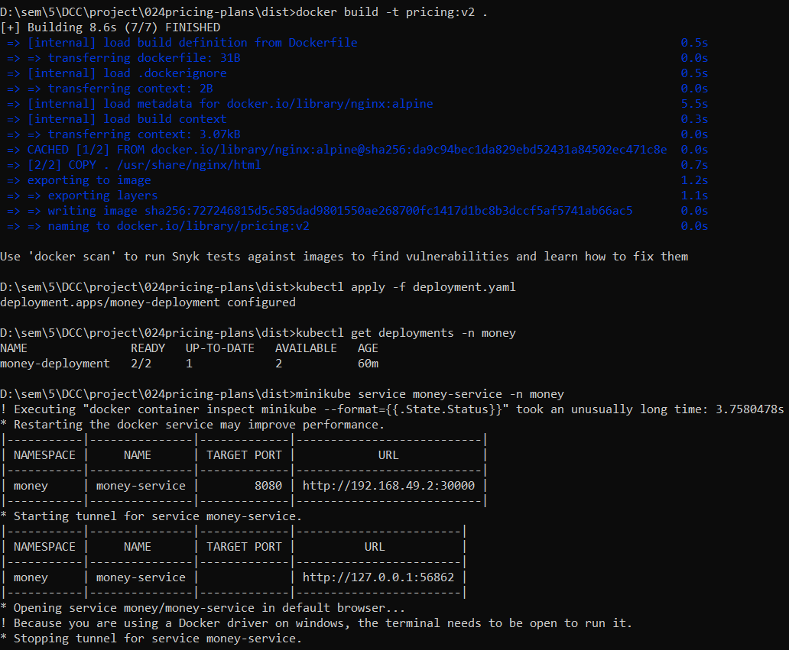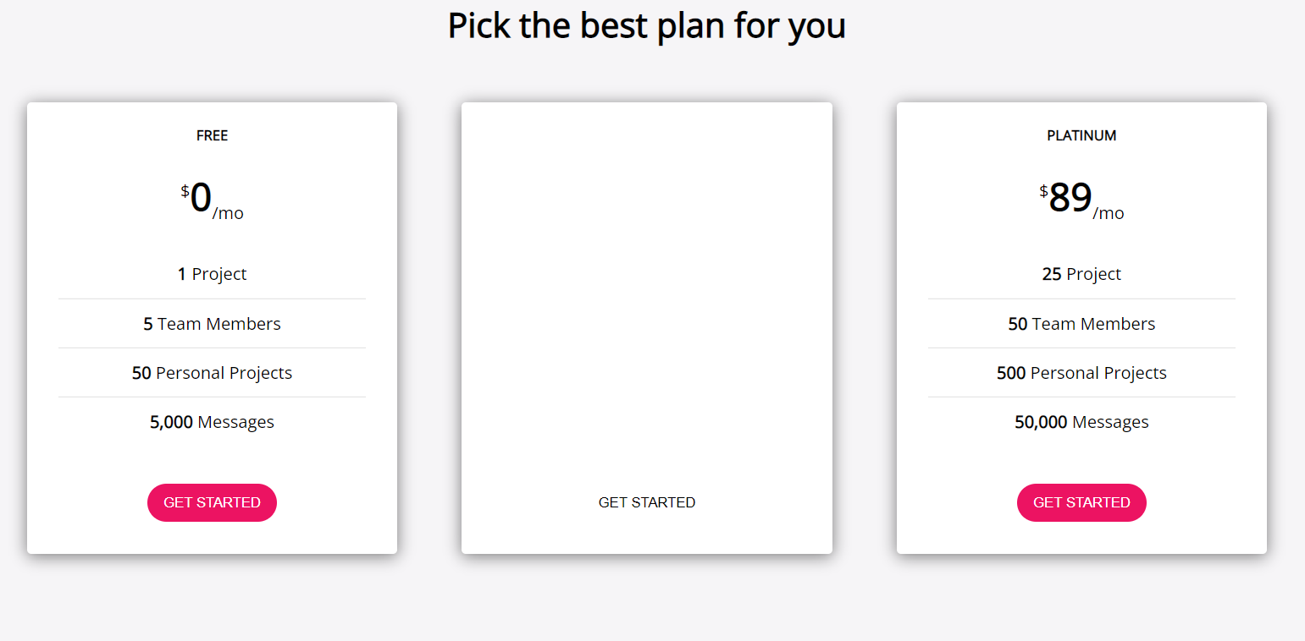

**Rolling back to version 1**: